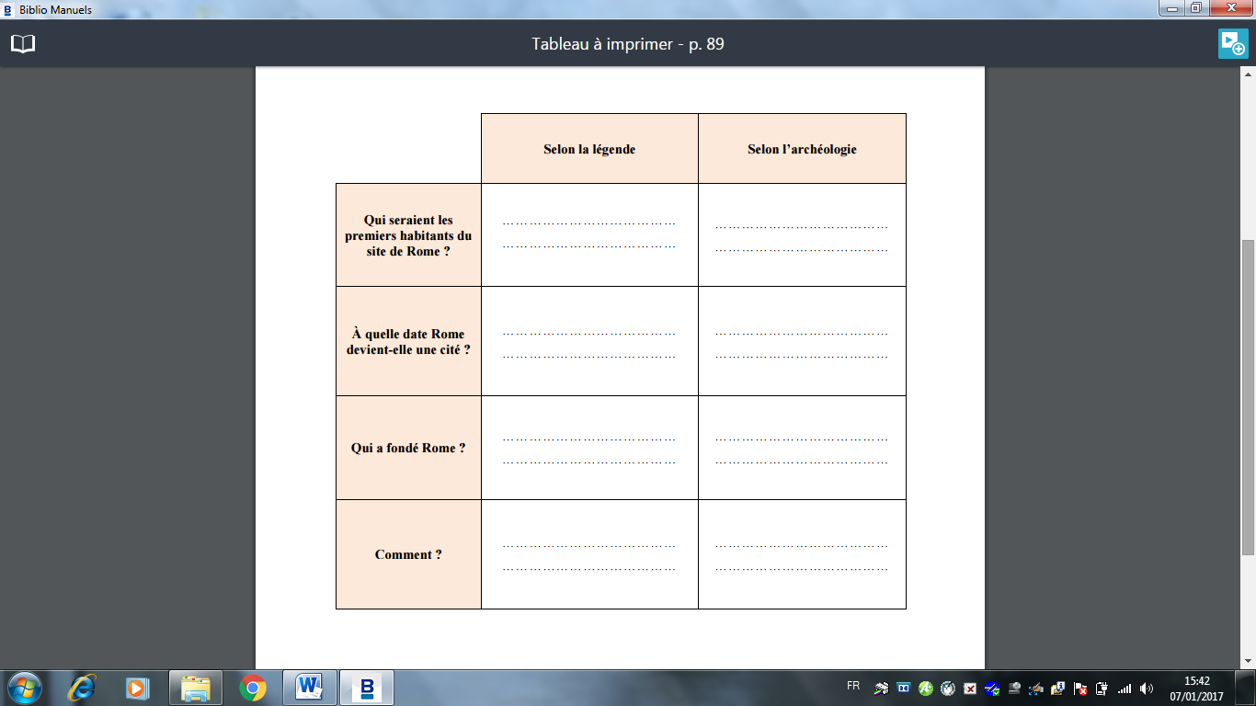

|  |  |
| --- | --- |
| C.3.4 |  |
| C.7.1 |  |

